Task 1: Provisioning an Amazon RDS Instance

Overview
In this step, I deployed a managed relational database using Amazon RDS (Relational Database Service). Using a managed service instead of manual installation on an EC2 instance reduces operational overhead and ensures better reliability.

Technical Specifications
- Database Engine: PostgreSQL (an open-source object-relational database).
- Instance Class: db.t3.micro (ideal for testing and low-traffic applications within the Free Tier).
- Storage: 20 GB General Purpose SSD (gp3).
- Region: eu-central-1 (Frankfurt).

Why this matters for Security & Operations:
- Managed Updates: AWS handles OS patching and database software updates, reducing the risk of vulnerabilities.
- Isolation: By placing the database in a specific subnet, we can control traffic using Security Groups, ensuring that only authorized applications (like a web server) can connect to it.
- Scalability: The t3.micro instance is a cost-effective starting point, but RDS allows for easy scaling as data requirements grow.
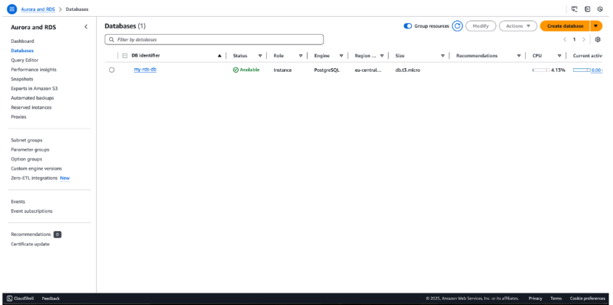

Task 2: Identifying the Database Endpoint

Overview
To connect any application to the database, we need its Endpoint. Think of the endpoint as the specific "home address" of your database on the internet (or within your private network).

Key Details
- Endpoint: This is a DNS name (e.g., my-rds-db.c123456789.eu-central-1.rds.amazonaws.com).
- Port: Default for PostgreSQL is 5432.

Security Perspective
Finding the endpoint is only the first step. In a secure environment:
- Private Access: The endpoint should ideally not be reachable from the public internet.
- Firewall (Security Groups): Even if someone has the endpoint address, they cannot connect unless their IP address is explicitly allowed in the AWS Security Group rules.
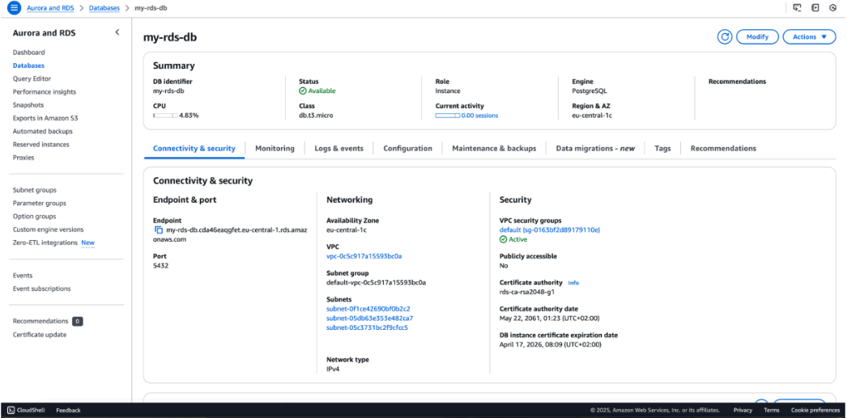

Task 3: Connecting via Command Line (psql)

Overview
Now that the database is running and the endpoint is known, I established a connection using psql, the command-line interface for PostgreSQL. This step verifies that the database is reachable and accepting connections.

The Command
I used the following command structure to log in: psql -h <endpoint> -U <username> -d postgres

Security & Educational Note
- Encrypted Connection: As seen in the screenshot, the connection uses SSL (TLSv1.3). This is crucial for cybersecurity because it encrypts the data in transit, preventing attackers from "sniffing" your database password or data over the network.
- Authentication: Access is granted only after providing the correct password for the databaseuser.
- Success Indicator: The postgres=> prompt confirms that we are inside the database and ready to execute SQL queries.
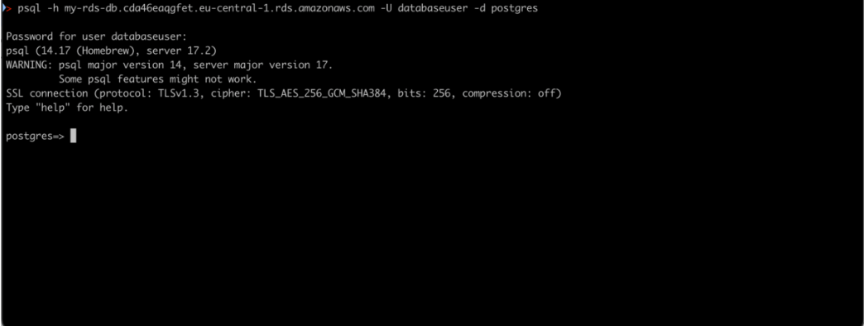

Task 4: Creating the Database Schema

Overview
Once connected, I defined the database structure by creating a table named users. This sets the foundation for how data will be stored and organized.

Table Structure Breakdown
- id: A unique identifier for each user, automatically incremented (SERIAL PRIMARY KEY).
- name: Stores the user's name (up to 100 characters).
- email: Stores the email address with a UNIQUE constraint.

Security & Best Practices
- Data Integrity: The UNIQUE constraint on the email field is a critical security and operational feature. It prevents duplicate accounts and ensures that each user has a distinct identity.
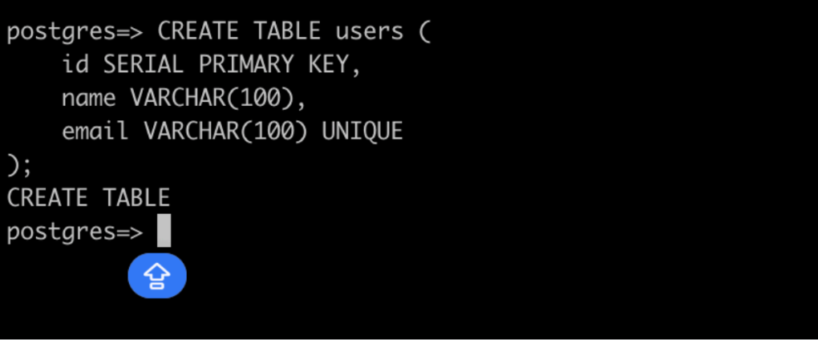
- Least Privilege: Defining specific data types (like VARCHAR(100)) instead of unlimited text helps optimize performance and prevents certain types of buffer-related issues.

Task 5: Populating the Database (Data Entry)

Overview
To verify that the database structure is functional, I inserted a test record into the users table. This step confirms that the system correctly handles write operations and follows the defined constraints.

The Query
I executed the following command to add a new user: INSERT INTO users (name, email) VALUES ('Іван', 'ivan@example.com');

Technical Observations
- Success Message: The response INSERT 0 1 indicates that one row was successfully added to the table.
- Automatic ID Generation: Since the id field was set to SERIAL, the database automatically assigned a unique number to this record behind the scenes.
- UTF-8 Support: The successful insertion of the name "Іван" confirms that the database correctly handles Cyrillic characters and Unicode encoding.

Cybersecurity Note
In a real-world application, data is never inserted directly like this from a user form. To prevent SQL Injection attacks, developers must use Parameterized Queries (Prepared Statements) to ensure that malicious code cannot be executed through input fields.

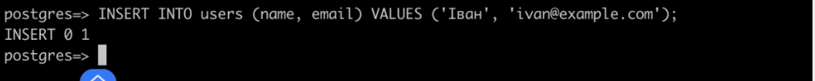
Task 6: Querying and Verifying Data

Overview
The final step is to retrieve the data from the database to ensure it was stored correctly. I used the SELECT statement, which is the primary tool for reading data in SQL.

The Query
I executed: SELECT * FROM users; (The asterisk * tells the database to return all columns from the specified table).

Technical Results
- Confirmation: The terminal successfully displayed the record for "Іван" with his email and the automatically assigned ID of 1.
- Data Persistence: This confirms that the RDS instance is not only accepting connections but is actively storing and retrieving data as expected.

Cybersecurity Tip
From a security standpoint, it is best practice to select only the specific columns you need (e.g., SELECT name FROM users;) rather than using SELECT *. This reduces the amount of sensitive data being sent over the network and minimizes the risk of accidental information disclosure.

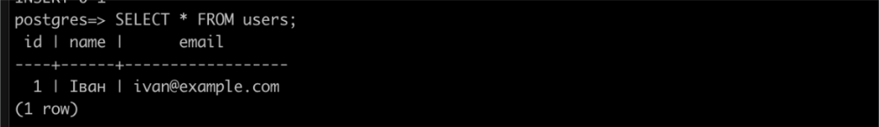

Task 7: Resource Cleanup (Deleting the RDS Instance)

Overview
The final step of this laboratory work was the secure decommissioning of the cloud resources. Deleting unused instances is a fundamental practice in cloud management to avoid unnecessary costs and minimize security risks.

Key Actions
- Termination: I initiated the deletion process through the Amazon RDS console.
- Final Snapshot (Optional): During deletion, AWS offers the option to create a final backup (snapshot). For this lab, I proceeded without a snapshot to fully clear the environment.

Why this matters for Cybersecurity & Operations:
- Cost Management: In a professional environment, "zombie" resources (unused but active) can lead to massive unexpected bills.
- Security Hygiene: Every active resource is a potential target. Deleting an instance after a project is finished ensures that an unmonitored database doesn't become a vulnerability in the future.
- Compliance: Proper disposal of data and resources is a requirement for many security frameworks (like SOC2 or ISO 27001).
